THE NATIONAL DIALECT FESTIVAL 2022
A celebration of England's Regional speech

Hosted by
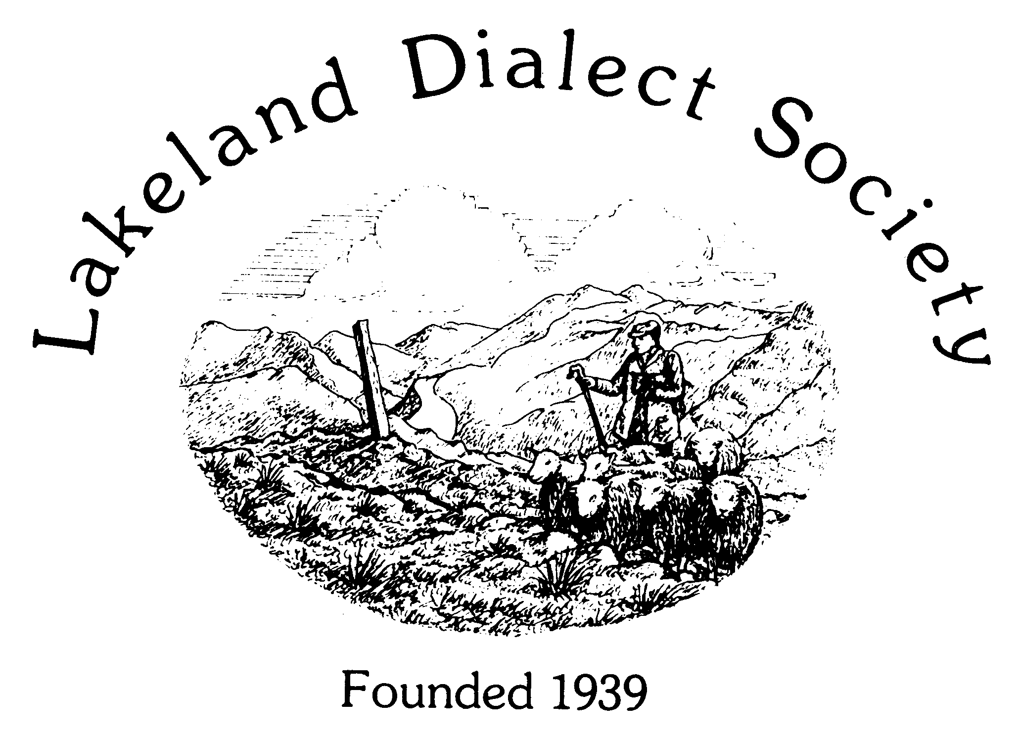
The
Lakeland
Dialect
Society

At Shap Wells Hotel, Shap near Penrith, CA10 3QU

Friday evening 28th
& Saturday 29th October

Talks, Competitions & Entertainment
Events open to the public

For details of booking and accommodation
please contact the Secretary lakespeak.jean@gmail.com
or visit www.lakelanddialectsociety.co.uk

