**PRESS RELEASE**

**Is dialect dying out?**

**Is dialect – the way we speak – dying out in Yorkshire?**

**According to Phillip Bell, Chief Executive of the Yorkshire Society “There is something unique and special about Yorkshire people – how we talk. The way we speak is unique and helps define us – it’s part of what makes us Yorkshire.”**

**To discover more about traditional Yorkshire accents and dialect and how they have changed in the 21st century, the Yorkshire Dales Society and Yorkshire Heritage Guardians the Yorkshire Dialect Society, are joining forces with the Friends of Keighley Library for a special Yorkshire Dialect Day. It is to be held in Keighley’s Local Studies Library on Saturday July 30th as part of Yorkshire Day weekend 2022 being hosted by Keighley Town Council and the Yorkshire Society.**

The day’s activities will include a talk by Ian Stevenson of the Yorkshire Dialect Society, explaining what Yorkshire dialect is, from early times to the present day, perhaps answering the question if it is dying out – or simply changing. Rod Dimbleby Chairman of the Yorkshire Dialect Society will be telling us about the life and work of the remarkable Halifax dialect scholar, writer, poet and editor John Hartley, 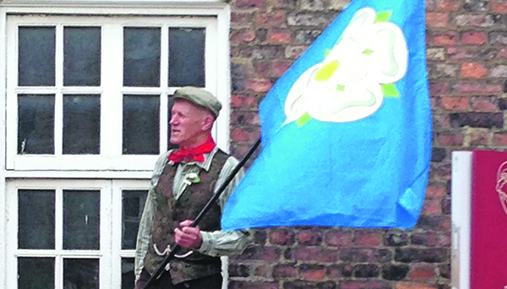 to be followed by that highly entertaining dialect raconteur Eric Scaife with some examples of traditional Yorkshire dialect humour in prose and verse.

There will also be an exhibition in the Local Studies Library of the work and life of Ian Dewhirst (1936-2019), celebrated local historian, dialect poet and storyteller.

**Tickets for this unique event, celebrating Yorkshire’s remarkable dialect and linguistic tradition, cost just £5 but because of space constraints, are limited so early booking is recommended – on**   [https://theyorkshiresociety.org/event/celebrating-the-yorkshire-dialect/.](https://theyorkshiresociety.org/event/celebrating-the-yorkshire-dialect/)

Photo Eric Scaife (Yorkshire Dialect Society)

-ends-

**For further details contact: Colin Speakman on 01943 470909**